Project Planning Phase
Project Planning Template (Product Backlog, Sprint Planning, Stories, Story points)

Date | 26 February 2026
Team ID | LTVIP2026TMIDS74388
Project Name | LAPTOP REQUEST CATALOG ITEM
Maximum Marks | 5 Marks

Product Backlog, Sprint Schedule, and Estimation (4 Marks)

Sprint | Functional Requirement (Epic) | User Story Number | User Story / Task | Story Points | Priority | Team Members
Sprint-1 | Laptop Request Form | USN-1 | As an employee, I can access a laptop request form in ServiceNow with guided fields. | 3 | High | Developer, UX
Sprint-1 | Laptop Request Form | USN-2 | As an employee, I see role-based laptop recommendations based on my job title. | 2 | High | Developer
Sprint-2 | Form Dynamics | USN-3 | As an employee, I see dynamic fields that change based on my selections (via UI Policies) | 3 | Medium | Developer, Tester
Sprint-1 | Form Functionality | USN-4 | As an employee, I can reset the form to correct errors before submission. | 1 | Medium | Developer
Sprint-1 | Approval Workflow | USN-5 | As a manager, I can approve or reject laptop requests with comments. | 2 | High | Developer, IT
Sprint-3 | Status Tracking | USN-6 | As an employee, I can see the real-time status of my laptop request. | 2 | Medium | Developer, UX
Sprint-3 | Integration | USN-7 | As IT staff, I can see laptop availability from CMDB during request processing | 3 | Low | Developer, IT
Sprint-2 | Notifications | USN-8 | As an employee, I receive email updates on request approval or rejection. | 1 | High | Developer

Developer/ Tester = Y.Lowshik Teja IT= B.Praveen
Ux = R. Hemachand UX/Developer = Mokshagna Sai

Project Tracker, Velocity & Burndown Chart: (4 Marks)
Sprint | Total Story Points | Duration | Sprint Start Date | Sprint End Date (Planned) | Story Points Completed (as on Planned End Date) | Sprint Release Date (Actual)
Sprint-1 | 7 | 4 Days | 13 Jun 2025 | 16 Jun 2025 | 7 | 16 Jun 2025
Sprint-2 | 5 | 4 Days | 17 Jun 2025 | 20 Jun 2025 | 5 | 20 Jun 2025
Sprint-3 | 5 | 5 Days | 21 Jun 2025 | 25 Jun 2025 | 5 | 25 Jun 2025

Velocity:
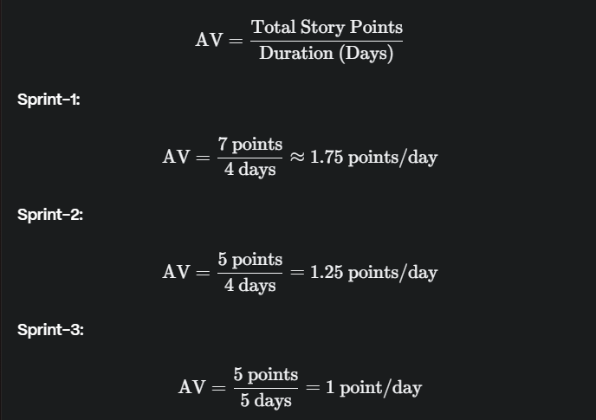
Sprint-1: Completed 7 story points in 4 days, with a higher velocity due to focused work on core functionalities.
Sprint-2: Completed 5 story points in 4 days, slightly lower velocity due to more complex tasks.
Sprint-3: Completed 5 story points in 5 days, the lowest velocity due to additional time required for testing and integrations.

